**CT303** **Digital Communication Autumn, 2018**

**Lab. 10Illustration of ASK,PSK, FSK and QPSK Generation and synchronous detection (No ISI and No noise case).**

1. Generate amplitude shift keyed (ASK) signal for binary pulse train. Demodulate the same using synchronous detection.

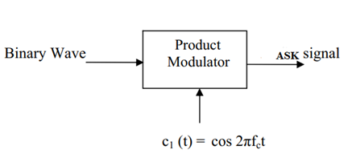

**ASK modulator**

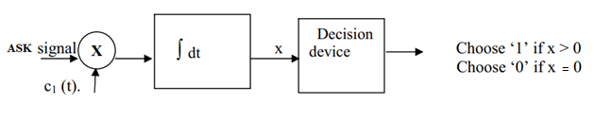

**ASK receiver (or demodulator)**

1. Generate phase shift keyed (PSK) signal for binary pulse train. Demodulate PSK signal.

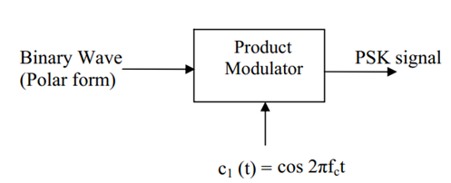

**PSK modulator**

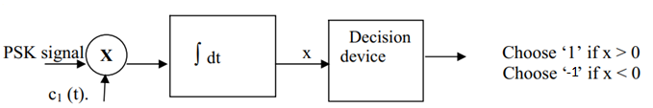

**PSK receiver**

1. Generate frequency shift keyed (FSK) signal for binary pulse train. Demodulate FSK signal.

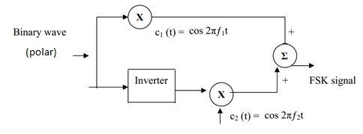

Binary wave – on-off

NOT polar

**FSK modulator**

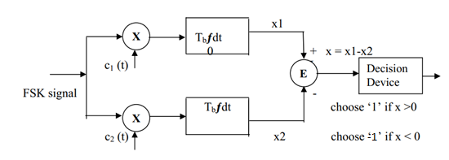

**FSK receiver**

1. Generate quadrature phaseshift keyed (QPSK: 4-ary PSK) signal. Demodulate the same.

Here $\sqrt{2/T}$ is for keeping unit energy. There are four message points

|  |  |
| --- | --- |
| Input | Phase of  QPSK signal |
| 10 | 45o |
| 00 | 135o |
| 01 | 225o |
| 11 | 315o |

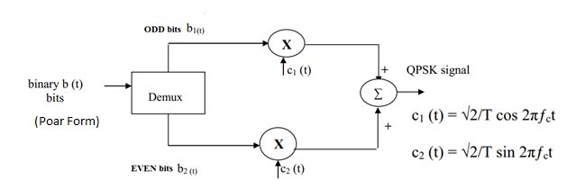

**QPSK modulator**

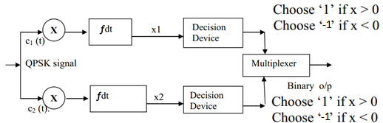

**QPSK receiver**

**Note:**

**We used the locally generated carrier at the receiver (with exact transmitted carrier frequency and received phase (in this case 0)). This is must for synchronous detection.**